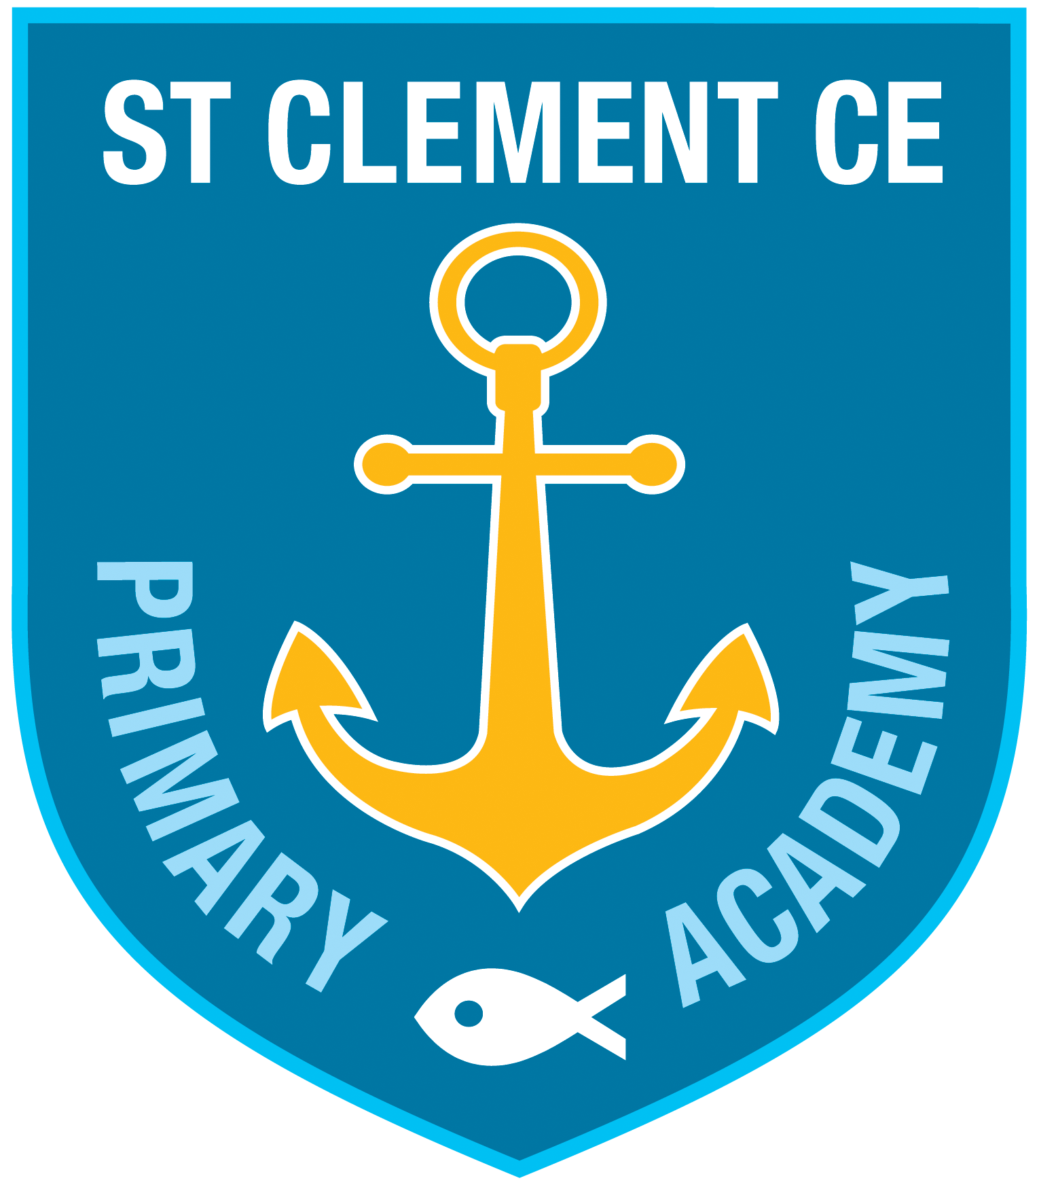
ST CLEMENT CE PRIMARY ACADEMY
A new school for Shoreham

Expression of Interest Form
Parents and carers who are considering applying for a place at St Clement CE Primary Academy are invited to complete and return the following:

Child’s name:

Date of birth:

School start date:

Name of parent:

Address:

Phone:

Email:

I would be interested in applying for a place at St Clement CE Primary Academy and would like further information. Yes/No

Signature:

Please return this form as soon as possible to St Nicolas
and St Mary Primary School, Eastern Avenue BN43 6PE
or email StClement@stnm.org.uk

