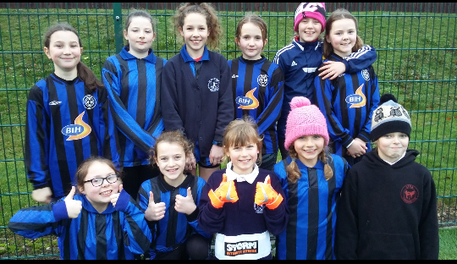

For many of the team, this was their first try at playing competitive football. Despite this they all played brilliantly and had a great time. Such was their enthusiasm, that they were awarded a special certificate recognising their determination. We are proud of them all.

