Beach Clean Parental Consent Form to take part in
The World’s Biggest Beach Clean,
Shoreham by Sea, March 4th 2018

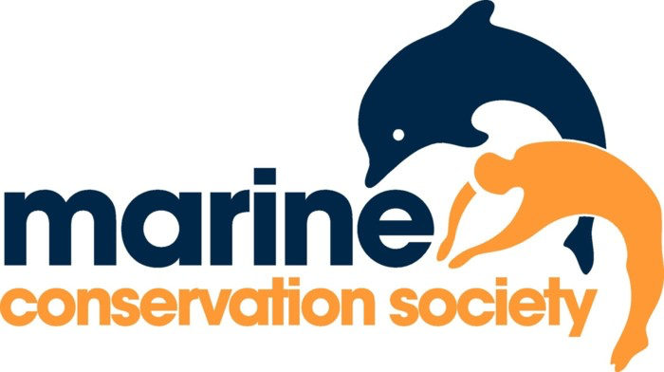
This form must be completed for each beach clean participant who is under 16 – please include all the children you are responsible for on this form. U-16's must be accompanied by a parent, relative, schoolteacher or someone who is legally responsible for
them, at all times. Please read the risk assessment (also attached to the email) before completing and signing this form prior to the clean. I give permission for the participant(s) to take part in all activities involved in the beach clean event and confirm that he/she has no medical conditions that make it inadvisable to participate

Child’s Name |  |  |  | Age
Child’s Name |  |  |  | Age
Child’s Name |  |  |  | Age
Child’s Name |  |  |  | Age
Child’s Name |  |  |  | Age

Parent / Guardian Details
First Name |  |  |  | Surname
Phone number during beach clean
Address |  |  |  | Postcode
Signature |  |  |  | Date

Photo consent
I give / I do not give consent for recognisable photography of my child / children to be taken, stored and used by Be The Change Books in future digital and printed publications, including third party publications

Signature

