Mia’s Story

One day there was a sad, Sassy in the rainforest who lost her family. Sadly people were making fun of her sass, and her family was also making fun of her sass before, she lost them and was really sad. So she started to cry and Sassy shouted “I want my parents”. She was the saddest she’d ever been in her whole life.
was so cross. Above the clouds, a invite fell in her hand and she screamed “I’ve got a invite to a party.” Sassy opened the invite as fast as a cheetah and the invite said “You’ve been invited to a party.” She was so excited that it was in one day time. She was cross and annoyed that she had to wait a day so she went to bed and fell fast asleep.
Early one morning, she woke up but there was a problem. There was a mummy attack she was so sad Sassy knew she couldn’t get there she
In the blink of eye, a nice bear came and kicked the mummy over. She was so proud if the bear. Sassy gave the bear a hug and said “Do you want to come to the party?”. “Yes I do”.After that they walked happily to the party.
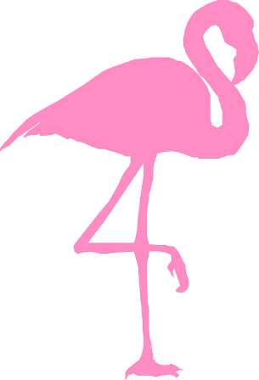
After that they opened the door as quick as a flash, and they heard rocking music and they smelt delicious food and disgusting smoke. Sassy ate chocolate and ice cream.

