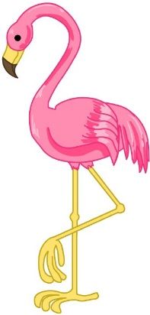
Once upon a time there lived a bird called Sassy who lived in a terrible rainforest! She wasn’t grumpy because she lived in a terrible rainforest it’s because she broke up with her friend Tango with a big argument! Poor Sassy was helpless.

One misty morning, Sassy an invitation from another bird she was so amazed she didn’t know what to say! She wanted it to be the ball! She was right she was fascinated.

One year later it was time for the ball she was going but all of a sudden her mean stepmother DIDN’T let her go because she needed to make the fire she tweeted and got other birds to help so she could go.

She went upstairs and got her grandest clothes on Sassy was ready to go she went on her horse and quickly went to the ball! As soon as she could, she got to the party she was so excited! She saw lots of people Sassy heard lots of shouting and tasted lots of cake! She got to dance with the prince of the birds she had so much fun.

THE END.

