Martins!

In the deep rainforest Sassy was very lonely in the dark muddy dirty Amazon rainforest. In the creepy rainforest was a bad witch who was magic she teleported Sassy in a high tree. Sassy said “get me down it’s getting dark!”

In the rainforest suddenly an invitation flew to Sassy. Sassy was so excited to open the letter so she did. It said ‘you are invited to the Jungle to the King’s party’.

In the jungle was an elephant that trapped the way through to the party. Suddenly the elephant was going to eat her into pieces. Next it was thinking what to do.

Finally she said “I am not going to eat you I am a vegetarian”. Next the elephant was OK. They finally were going to the party.

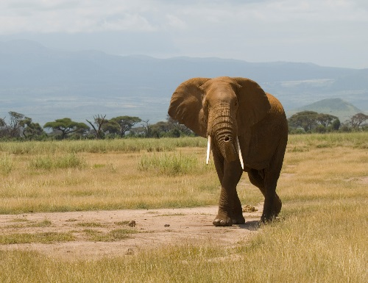
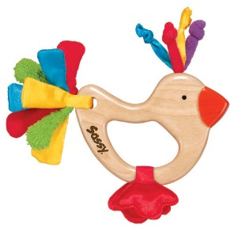
She and the elephant went together to the party.

