St Nicolas & St Mary CE Primary
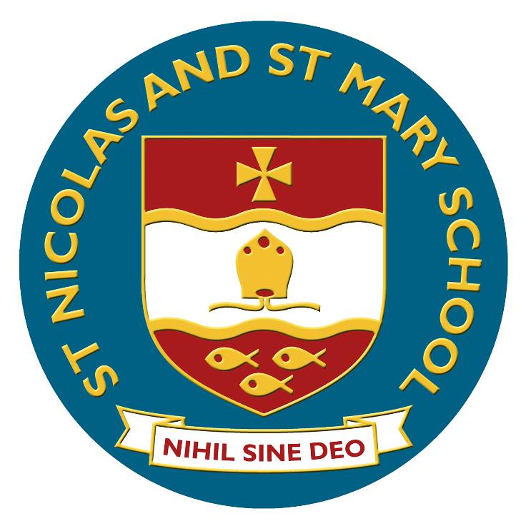

Y3/4 Spelling

Spelling – work for years 3 and 4

Statutory requirements |  | Rules and guidance (non-statutory) | Example words (non-statutory)
Adding suffixes beginning with vowel letters to words of more than one syllable |  | If the last syllable of a word is stressed and ends with one consonant letter which has just one vowel letter before it, the final consonant letter is doubled before any ending beginning with a vowel letter is added. The consonant letter is not doubled if the syllable is unstressed. | forgetting, forgotten, beginning, beginner, prefer, preferred  gardening, gardener, limiting, limited, limitation
The /ɪ/ sound spelt y elsewhere than at the end of words |  | These words should be learnt as needed. | myth, gym, Egypt, pyramid, mystery
The /ʌ/ sound spelt ou |  | These words should be learnt as needed. | young, touch, double, trouble, country
More prefixes |  | Most prefixes are added to the beginning of root words without any changes in spelling, but see in– below.
 |  | Like un–, the prefixes dis– and mis– have negative meanings. | dis–: disappoint, disagree, disobey  mis–: misbehave, mislead, misspell (mis + spell)
 |  | The prefix in– can mean both ‘not’ and ‘in’/‘into’. In the words given here it means ‘not’. | in–: inactive, incorrect

Statutory requirements |  | Rules and guidance (non-statutory) | Example words (non-statutory)
 |  | Before a root word starting with l, in– becomes il. | illegal, illegible
 |  | Before a root word starting with m or p, in– becomes im–. | immature, immortal, impossible, impatient, imperfect
 |  | Before a root word starting with r, in– becomes ir–. | irregular, irrelevant, irresponsible
 |  | re– means ‘again’ or ‘back’. | re–: redo, refresh, return, reappear, redecorate
 |  | sub– means ‘under’. | sub–: subdivide, subheading, submarine, submerge
 |  | inter– means ‘between’ or ‘among’. | inter–: interact, intercity, international, interrelated (inter + related)
 |  | super– means ‘above’. | super–: supermarket, superman, superstar
 |  | anti– means ‘against’. | anti–: antiseptic, anti-clockwise, antisocial
 |  | auto– means ‘self’ or ‘own’. | auto–: autobiography, autograph
The suffix –ation |  | The suffix –ation is added to verbs to form nouns. The rules already learnt still apply. | information, adoration, sensation, preparation, admiration
The suffix –ly |  | The suffix –ly is added to an adjective to form an adverb. The rules already learnt still apply.  The suffix –ly starts with a consonant letter, so it is added straight on to most root words. | sadly, completely, usually (usual + ly), finally (final + ly), comically (comical + ly)

Statutory requirements |  | Rules and guidance (non-statutory) | Example words (non-statutory)
 |  | Exceptions:  (1) If the root word ends in –y with a consonant letter before it, the y is changed to i, but only if the root word has more than one syllable. | happily, angrily
 |  | (2) If the root word ends with –le, the –le is changed to –ly. | gently, simply, humbly, nobly
 |  | (3/4) If the root word ends with –ic,  –ally is added rather than just –ly, except in the word publicly. | basically, frantically, dramatically
 |  | (4) The words truly, duly, wholly.
Words with endings sounding like /ʒə/ or /tʃə/ |  | The ending sounding like /ʒə/ is always spelt –sure.  The ending sounding like /tʃə/ is often spelt –ture, but check that the word is not a root word ending in (t)ch with an er ending – e.g. teacher, catcher, richer, stretcher. | measure, treasure, pleasure, enclosure  creature, furniture, picture, nature, adventure
Endings which sound like /ʒən/ |  | If the ending sounds like /ʒən/, it is spelt as –sion. | division, invasion, confusion, decision, collision, television
The suffix –ous |  | Sometimes the root word is obvious and the usual rules apply for adding suffixes beginning with vowel letters.  Sometimes there is no obvious root word.  –our is changed to –or before –ous is added.  A final ‘e’ of the root word must be kept if the /dʒ/ sound of ‘g’ is to be kept.  If there is an /i:/ sound before the  –ous ending, it is usually spelt as i, but a few words have e. | poisonous, dangerous, mountainous, famous, various  tremendous, enormous, jealous  humorous, glamorous, vigorous  courageous, outrageous  serious, obvious, curious  hideous, spontaneous, courteous

Statutory requirements |  | Rules and guidance (non-statutory) | Example words (non-statutory)
Endings which sound like /ʃən/, spelt –tion, –sion, –ssion, –cian |  | Strictly speaking, the suffixes are –ion and –ian. Clues about whether to put t, s, ss or c before these suffixes often come from the last letter or letters of the root word.  –tion is the most common spelling. It is used if the root word ends in t or te.  –ssion is used if the root word ends in ss or –mit.  –sion is used if the root word ends in d or se.  Exceptions: attend – attention, intend – intention.  –cian is used if the root word ends in c or cs. | invention, injection, action, hesitation, completion  expression, discussion, confession, permission, admission  expansion, extension, comprehension, tension  musician, electrician, magician, politician, mathematician
Words with the /k/ sound spelt ch (Greek in origin) |  |  | scheme, chorus, chemist, echo, character
Words with the /ʃ/ sound spelt ch (mostly French in origin) |  |  | chef, chalet, machine, brochure
Words ending with the /g/ sound spelt –gue and the /k/ sound spelt –que (French in origin) |  |  | league, tongue, antique, unique
Words with the /s/ sound spelt sc (Latin in origin) |  | In the Latin words from which these words come, the Romans probably pronounced the c and the k as two sounds rather than one – /s/ /k/. | science, scene, discipline, fascinate, crescent
Words with the /eɪ/ sound spelt ei, eigh, or ey |  |  | vein, weigh, eight, neighbour, they, obey

Statutory requirements |  | Rules and guidance (non-statutory) | Example words (non-statutory)
Possessive apostrophe with plural words |  | The apostrophe is placed after the plural form of the word; –s is not added if the plural already ends in  –s, but is added if the plural does not end in –s (i.e. is an irregular plural – e.g. children’s). | girls’, boys’, babies’, children’s, men’s, mice’s  (Note: singular proper nouns ending in an s use the ’s suffix e.g. Cyprus’s population)
Homophones and near-homophones |  |  | accept/except, affect/effect, ball/bawl, berry/bury, brake/break, fair/fare, grate/great, groan/grown, here/hear, heel/heal/he’ll, knot/not, mail/male, main/mane, meat/meet, medal/meddle, missed/mist, peace/piece, plain/plane, rain/rein/reign, scene/seen, weather/whether, whose/who’s

Word list – years 3 and 4

accident(ally)
actual(ly)
address
answer
appear
arrive
believe
bicycle
breath
breathe
build
busy/business
calendar
caught
centre
century
certain
circle
complete
consider
continue
decide
describe
different
difficult
disappear
early
earth
eight/eighth
enough
exercise
experience
experiment
extreme
famous
favourite
February
forward(s)
fruit
grammar
group
guard
guide
heard
heart
height
history
imagine
increase
important
interest
island
knowledge
learn
length
library
material
medicine
mention
minute
natural
naughty
notice
occasion(ally)
often
opposite
ordinary
particular
peculiar
perhaps
popular
position
possess(ion)
possible
potatoes
pressure
probably
promise
purpose
quarter
question
recent
regular
reign
remember
sentence
separate
special
straight
strange
strength
suppose
surprise
therefore
though/although
thought
through
various
weight
woman/women

