St Nicolas & St Mary CE Primary
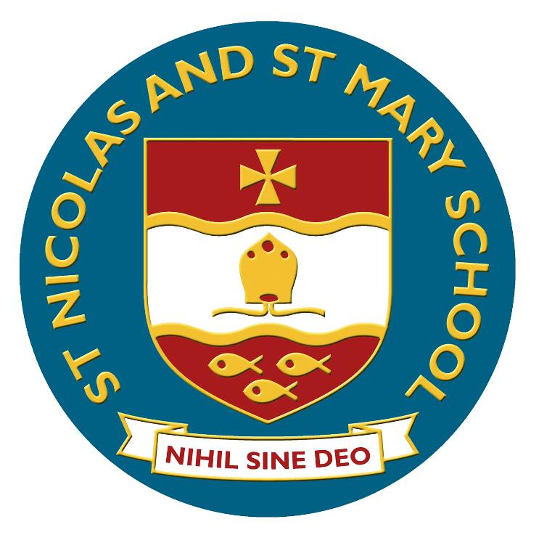

Y1/2 Spelling

Spelling – work for year 1

Statutory requirements |  | Rules and guidance (non-statutory) | Example words (non-statutory)
The sounds /f/, /l/, /s/, /z/ and /k/ spelt ff, ll, ss, zz and ck |  | The /f/, /l/, /s/, /z/ and /k/ sounds are usually spelt as ff, ll, ss, zz and ck if they come straight after a single vowel letter in short words. Exceptions: if, pal, us, bus, yes. | off, well, miss, buzz, back
The /ŋ/ sound spelt n before k |  |  | bank, think, honk, sunk
Division of words into syllables |  | Each syllable is like a ‘beat’ in the spoken word. Words of more than one syllable often have an unstressed syllable in which the vowel sound is unclear. | pocket, rabbit, carrot, thunder, sunset

Statutory requirements |  | Rules and guidance (non-statutory) | Example words (non-statutory)
-tch |  | The /tʃ/ sound is usually spelt as tch if it comes straight after a single vowel letter. Exceptions: rich, which, much, such. | catch, fetch, kitchen, notch, hutch
The /v/ sound at the end of words |  | English words hardly ever end with the letter v, so if a word ends with a /v/ sound, the letter e usually needs to be added after the ‘v’. | have, live, give
Adding s and es to words (plural of nouns and the third person singular of verbs) |  | If the ending sounds like /s/ or /z/, it is spelt as –s. If the ending sounds like /ɪz/ and forms an extra syllable or ‘beat’ in the word, it is spelt as –es. | cats, dogs, spends, rocks, thanks, catches
Adding the endings –ing, –ed and –er to verbs where no change is needed to the root word |  | –ing and –er always add an extra syllable to the word and –ed sometimes does.  The past tense of some verbs may sound as if it ends in /ɪd/ (extra syllable), /d/ or /t/ (no extra syllable), but all these endings are spelt –ed.  If the verb ends in two consonant letters (the same or different), the ending is simply added on. | hunting, hunted, hunter, buzzing, buzzed, buzzer, jumping, jumped, jumper
Adding –er and –est to adjectives where no change is needed to the root word |  | As with verbs (see above), if the adjective ends in two consonant letters (the same or different), the ending is simply added on. | grander, grandest, fresher, freshest, quicker, quickest

Vowel digraphs and trigraphs |  | Rules and guidance (non-statutory) | Example words (non-statutory)
ai, oi |  | The digraphs ai and oi are virtually never used at the end of English words. | rain, wait, train, paid, afraid  oil, join, coin, point, soil
ay, oy |  | ay and oy are used for those sounds at the end of words and at the end of syllables. | day, play, say, way, stay  boy, toy, enjoy, annoy
a–e |  |  | made, came, same, take, safe
e–e |  |  | these, theme, complete
i–e |  |  | five, ride, like, time, side
o–e |  |  | home, those, woke, hope, hole
u–e |  | Both the /u:/ and /ju:/ (‘oo’ and ‘yoo’) sounds can be spelt as u–e. | June, rule, rude, use, tube, tune
ar |  |  | car, start, park, arm, garden
ee |  |  | see, tree, green, meet, week
ea (/i:/) |  |  | sea, dream, meat, each, read (present tense)
ea (/ɛ/) |  |  | head, bread, meant, instead, read (past tense)
er (/ɜ:/) |  |  | (stressed sound): her, term, verb, person
er (/ə/) |  |  | (unstressed schwa sound): better, under, summer, winter, sister
ir |  |  | girl, bird, shirt, first, third
ur |  |  | turn, hurt, church, burst, Thursday

Vowel digraphs and trigraphs |  | Rules and guidance (non-statutory) | Example words (non-statutory)
oo (/u:/) |  | Very few words end with the letters oo, although the few that do are often words that primary children in year 1 will encounter, for example, zoo | food, pool, moon, zoo, soon
oo (/ʊ/) |  |  | book, took, foot, wood, good
oa |  | The digraph oa is very rare at the end of an English word. | boat, coat, road, coach, goal
oe |  |  | toe, goes
ou |  | The only common English word ending in ou is you. | out, about, mouth, around, sound
ow (/aʊ/)  ow (/əʊ/)  ue  ew |  | Both the /u:/ and /ju:/ (‘oo’ and ‘yoo’) sounds can be spelt as u–e, ue and ew. If words end in the /oo/ sound, ue and ew are more common spellings than oo. | now, how, brown, down, town  own, blow, snow, grow, show  blue, clue, true, rescue, Tuesday  new, few, grew, flew, drew, threw
ie (/aɪ/) |  |  | lie, tie, pie, cried, tried, dried
ie (/i:/) |  |  | chief, field, thief
igh |  |  | high, night, light, bright, right
or |  |  | for, short, born, horse, morning
ore |  |  | more, score, before, wore, shore
aw |  |  | saw, draw, yawn, crawl
au |  |  | author, August, dinosaur, astronaut
air |  |  | air, fair, pair, hair, chair
ear |  |  | dear, hear, beard, near, year
ear (/ɛə/) |  |  | bear, pear, wear
are (/ɛə/) |  |  | bare, dare, care, share, scared

Statutory requirements |  | Rules and guidance (non-statutory) | Example words (non-statutory)
Words ending –y (/i:/ or /ɪ/) |  |  | very, happy, funny, party, family
New consonant spellings ph and wh |  | The /f/ sound is not usually spelt as ph in short everyday words (e.g. fat, fill, fun). | dolphin, alphabet, phonics, elephant  when, where, which, wheel, while
Using k for the /k/ sound |  | The /k/ sound is spelt as k rather than as c before e, i and y. | Kent, sketch, kit, skin, frisky
Adding the prefix –un |  | The prefix un– is added to the beginning of a word without any change to the spelling of the root word. | unhappy, undo, unload, unfair, unlock
Compound words |  | Compound words are two words joined together. Each part of the longer word is spelt as it would be if it were on its own. | football, playground, farmyard, bedroom, blackberry
Common exception words |  | Pupils’ attention should be drawn to the grapheme-phoneme correspondences that do and do not fit in with what has been taught so far. | the, a, do, to, today, of, said, says, are, were, was, is, his, has, I, you, your, they, be, he, me, she, we, no, go, so, by, my, here, there, where, love, come, some, one, once, ask, friend, school, put, push, pull, full, house, our – and/or others, according to the programme used

Spelling – work for year 2

Statutory requirements |  | Rules and guidance (non-statutory) | Example words (non-statutory)
The /dʒ/ sound spelt as ge and dge at the end of words, and sometimes spelt as g elsewhere in words before e, i and y |  | The letter j is never used for the /dʒ/ sound at the end of English words.  At the end of a word, the /dʒ/ sound is spelt –dge straight after the /æ/, /ɛ/, /ɪ/, /ɒ/, /ʌ/ and /ʊ/ sounds (sometimes called ‘short’ vowels).  After all other sounds, whether vowels or consonants, the /dʒ/ sound is spelt as –ge at the end of a word.  In other positions in words, the /dʒ/ sound is often (but not always) spelt as g before e, i, and y. The /dʒ/ sound is always spelt as j before a, o and u. | badge, edge, bridge, dodge, fudge  age, huge, change, charge, bulge, village  gem, giant, magic, giraffe, energy  jacket, jar, jog, join, adjust
The /s/ sound spelt c before e, i and y |  |  | race, ice, cell, city, fancy
The /n/ sound spelt kn and (less often) gn at the beginning of words |  | The ‘k’ and ‘g’ at the beginning of these words was sounded hundreds of years ago. | knock, know, knee, gnat, gnaw
The /r/ sound spelt wr at the beginning of words |  | This spelling probably also reflects an old pronunciation. | write, written, wrote, wrong, wrap
The /l/ or /əl/ sound spelt –le at the end of words |  | The –le spelling is the most common spelling for this sound at the end of words. | table, apple, bottle, little, middle

Statutory requirements |  | Rules and guidance (non-statutory) | Example words (non-statutory)
The /l/ or /əl/ sound spelt –el at the end of words |  | The –el spelling is much less common than –le.  The –el spelling is used after m, n, r, s, v, w and more often than not after s. | camel, tunnel, squirrel, travel, towel, tinsel
The /l/ or /əl/ sound spelt –al at the end of words |  | Not many nouns end in –al, but many adjectives do. | metal, pedal, capital, hospital, animal
Words ending –il |  | There are not many of these words. | pencil, fossil, nostril
The /aɪ/ sound spelt –y at the end of words |  | This is by far the most common spelling for this sound at the end of words. | cry, fly, dry, try, reply, July
Adding –es to nouns and verbs ending in  –y |  | The y is changed to i before –es is added. | flies, tries, replies, copies, babies, carries
Adding –ed, –ing, –er and –est to a root word ending in –y with a consonant before it |  | The y is changed to i before –ed, –er and –est are added, but not before –ing as this would result in ii. The only ordinary words with ii are skiing and taxiing. | copied, copier, happier, happiest, cried, replied  …but copying, crying, replying
Adding the endings –ing, –ed, –er, –est and –y to words ending in –e with a consonant before it |  | The –e at the end of the root word is dropped before –ing, –ed, –er,  –est, –y or any other suffix beginning with a vowel letter is added. Exception: being. | hiking, hiked, hiker, nicer, nicest, shiny
Adding –ing, –ed,  –er, –est and –y to words of one syllable ending in a single consonant letter after a single vowel letter |  | The last consonant letter of the root word is doubled to keep the /æ/, /ɛ/, /ɪ/, /ɒ/ and /ʌ/ sound (i.e. to keep the vowel ‘short’).  Exception: The letter ‘x’ is never doubled: mixing, mixed, boxer, sixes. | patting, patted, humming, hummed, dropping, dropped, sadder, saddest, fatter, fattest, runner, runny
The /ɔ:/ sound spelt a before l and ll |  | The /ɔ:/ sound (‘or’) is usually spelt as a before l and ll. | all, ball, call, walk, talk, always
The /ʌ/ sound spelt o |  |  | other, mother, brother, nothing, Monday

Statutory requirements |  | Rules and guidance (non-statutory) | Example words (non-statutory)
The /i:/ sound spelt  –ey |  | The plural of these words is formed by the addition of –s (donkeys, monkeys, etc.). | key, donkey, monkey, chimney, valley
The /ɒ/ sound spelt a after w and qu |  | a is the most common spelling for the /ɒ/ (‘hot’) sound after w and qu. | want, watch, wander, quantity, squash
The /ɜ:/ sound spelt or after w |  | There are not many of these words. | word, work, worm, world, worth
The /ɔ:/ sound spelt ar after w |  | There are not many of these words. | war, warm, towards
The /ʒ/ sound spelt s |  |  | television, treasure, usual
The suffixes –ment,  –ness, –ful , –less and –ly |  | If a suffix starts with a consonant letter, it is added straight on to most root words without any change to the last letter of those words.  Exceptions:  (1) argument  (2) root words ending in –y with a consonant before it but only if the root word has more than one syllable. | enjoyment, sadness, careful, playful, hopeless, plainness (plain + ness), badly  merriment, happiness, plentiful, penniless, happily
Contractions |  | In contractions, the apostrophe shows where a letter or letters would be if the words were written in full (e.g. can’t – cannot).  It’s means it is (e.g. It’s raining) or sometimes it has (e.g. It’s been raining), but it’s is never used for the possessive. | can’t, didn’t, hasn’t, couldn’t, it’s, I’ll
The possessive apostrophe (singular nouns) |  |  | Megan’s, Ravi’s, the girl’s, the child’s, the man’s
Words ending in –tion |  |  | station, fiction, motion, national, section

Statutory requirements |  | Rules and guidance (non-statutory) | Example words (non-statutory)
Homophones and near-homophones |  | It is important to know the difference in meaning between homophones. | there/their/they’re, here/hear, quite/quiet, see/sea, bare/bear, one/won, sun/son, to/too/two, be/bee, blue/blew, night/knight
Common exception words |  | Some words are exceptions in some accents but not in others – e.g. past, last, fast, path and bath are not exceptions in accents where the a in these words is pronounced /æ/, as in cat.  Great, break and steak are the only common words where the /eɪ/ sound is spelt ea. | door, floor, poor, because, find, kind, mind, behind, child, children*, wild, climb, most, only, both, old, cold, gold, hold, told, every, everybody, even, great, break, steak, pretty, beautiful, after, fast, last, past, father, class, grass, pass, plant, path, bath, hour, move, prove, improve, sure, sugar, eye, could, should, would, who, whole, any, many, clothes, busy, people, water, again, half, money, Mr, Mrs, parents, Christmas – and/or others according to programme used.  Note: ‘children’ is not an exception to what has been taught so far but is included because of its relationship with ‘child’.

