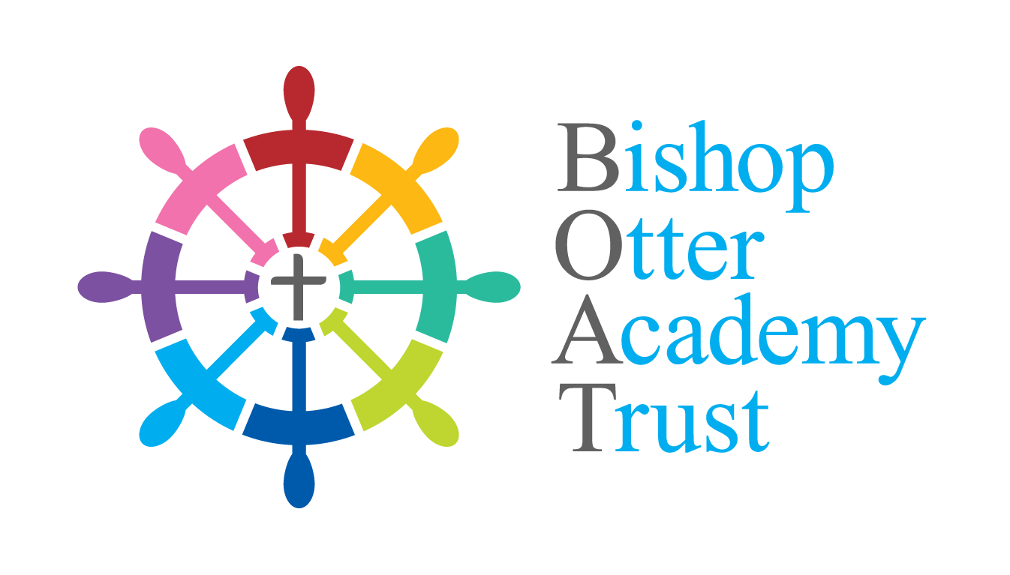
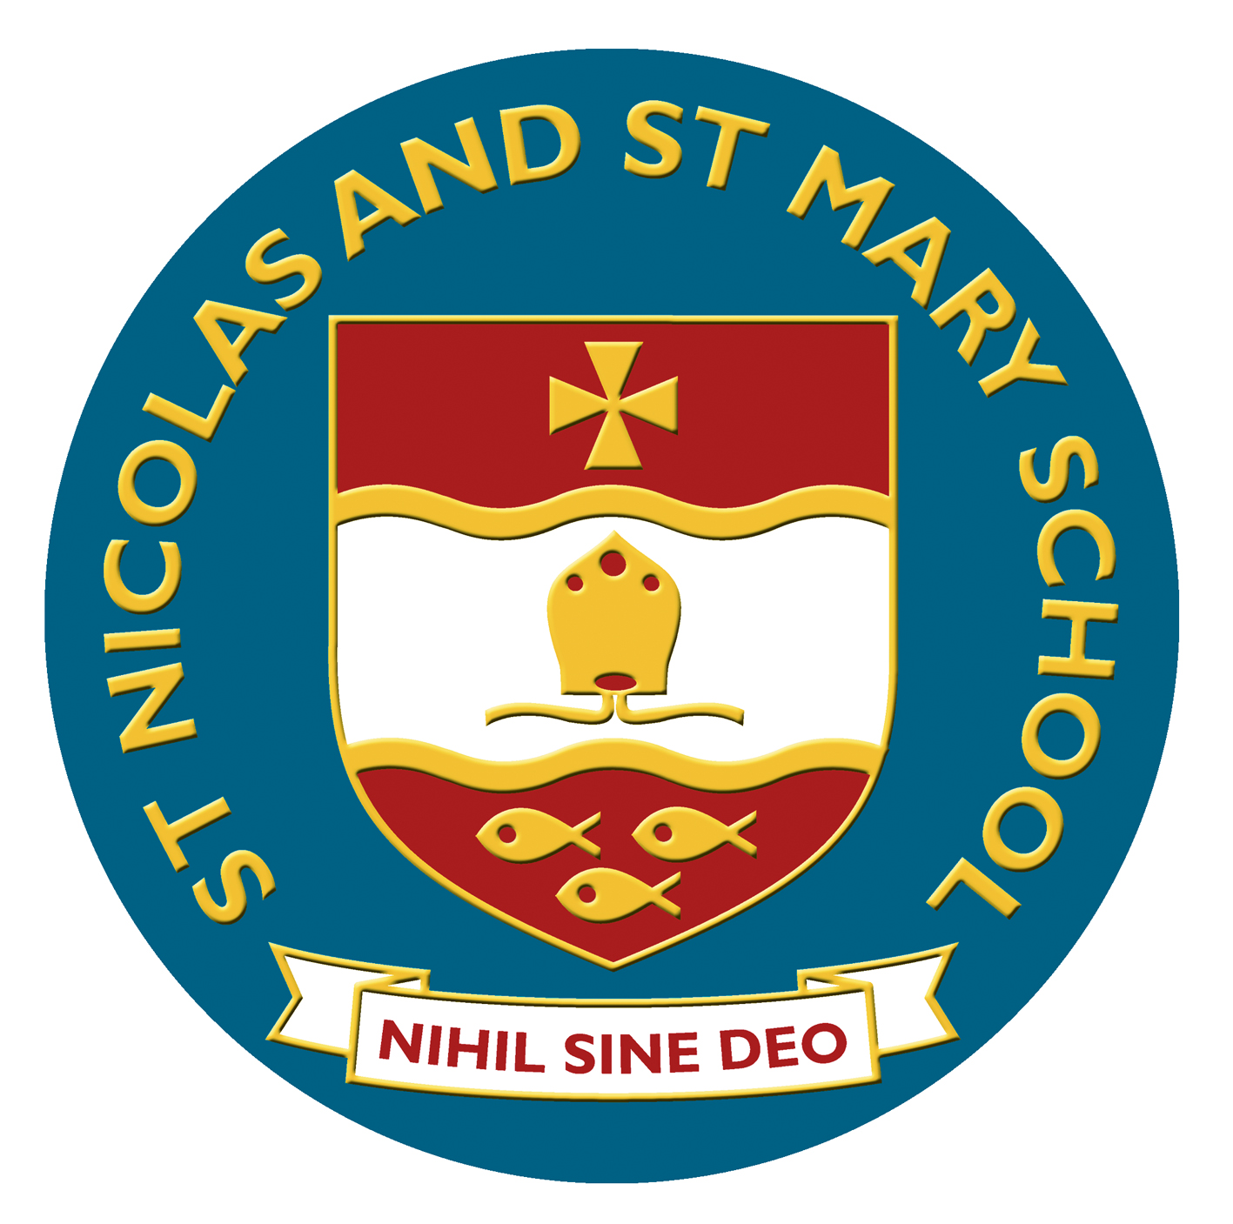
St Nicolas and St Mary CE Primary School
Eastern Avenue, Shoreham-by-Sea, West Sussex BN43 6PE
Tel: 01273 454470 Email: office@stnm.org.uk
Web: www.stnicolasmary.w-sussex.sch.uk

Headteacher Mr A Lincoln BA Hons
Executive Headteacher Mr D Etherton B.Ed Hons. NPQH

FORM OF ACCEPTANCE FOR ADMISSION
ACADEMIC YEAR 2023/24

Please complete in CAPITALS and return to the school by Thursday 25th May 2023.
Child’s Surname: |  |  |  |  |  | Forename:
Male | Female | Date of Birth:
Is the name above your child’s legal name?
Please state evidence of legal name (Birth certificate, deed poll document):

Surname of parents if different from child’s:
Address:
 |  |  |  |  |  |  |  | Post Code:
Tel: |  | Email:
School/Nursery/Playgroup attending at present:

(please tick appropriately)
□ I/We accept the place offered and attach a copy of my/our 2023/2024 Council Tax statement.

□ I/We do not need the place allocated as I/we have made the following alternative arrangements:

If your address has or will be changing before September 2023 you must notify the Pupil Admissions Team
without delay.

We reserve the right to request further supporting documentation where necessary to confirm residence
at the application address – places secured using false information will be withdrawn.

Your place may be offered to another child if the school does not receive this completed acceptance form.

By signing this form I confirm that I have parental responsibility for this child and that all the information
given here and in the application is legal and true.

Signed: | Date:
Print Name: | Relationship to the child:

