
ADHD Awareness Month
October 2025
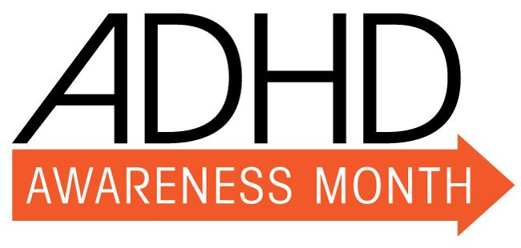
The month of October marks ADHD awareness month.
This year, the theme is:

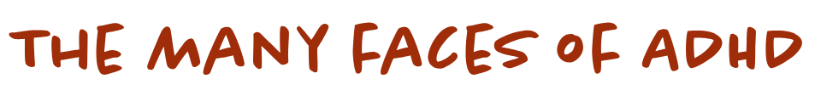

STORIES
Click above to find stories and experiences of people with ADHD
www.adhdawarenessmonth.org, would like to ‘encourage the ADHD community to increase awareness and understanding by sharing ADHD information and supports with all who could benefit’


magazine articles for educators

Strategies to Help ADHD Students, for Teachers (additudemag.com)
Mom's Advice for Teachers of ADHD Students (additudemag.com)
Explaining ADHD to Teachers: Back-to-School Resource (additudemag.com)
ADHD in the Classroom: 7 Overlooked Signs of ADD at School (additudemag.com)

ADHD and Autism- AuDHD
Emerging research is highlighting the co-occurrence of ADHD and Autism. The Learning Behaviour Advisory Team and the Autism and Social Communication Team are working collaboratively to create further training which will introduce school staff to this concept and how this may affect young people you work with. More information will follow.
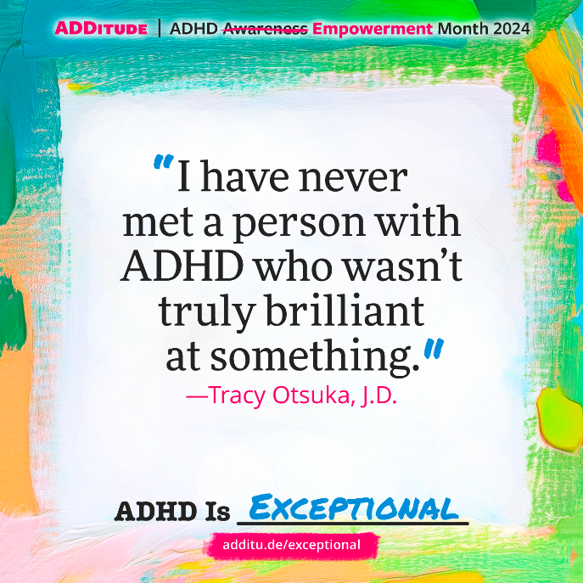
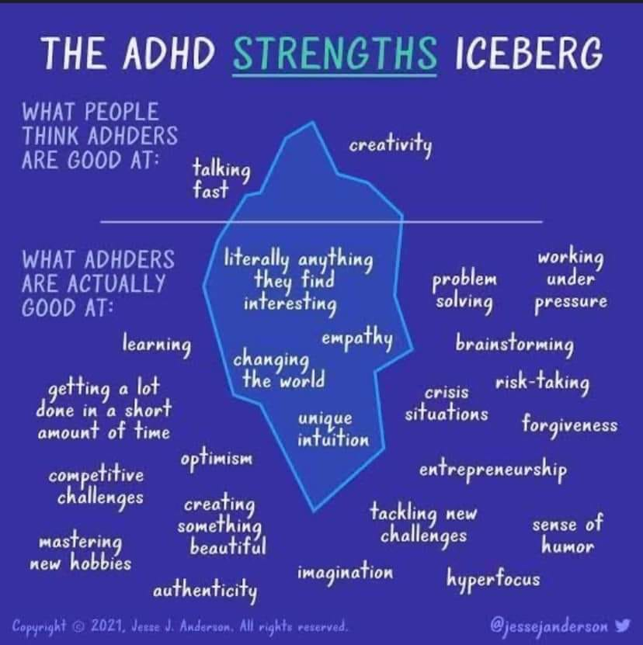

To support a young person to understand their ADHD diagnosis https://www.adhdfoundation.org.uk/wp-content/uploads/2022/10/ADHD-Activity-Book.pdf

Secondary age pupils may like https://www.adhdfoundation.org.uk/wp-content/uploads/2022/03/Hi-RES-ADHD-Foundation-Umbrella-Gang-comic.pdf

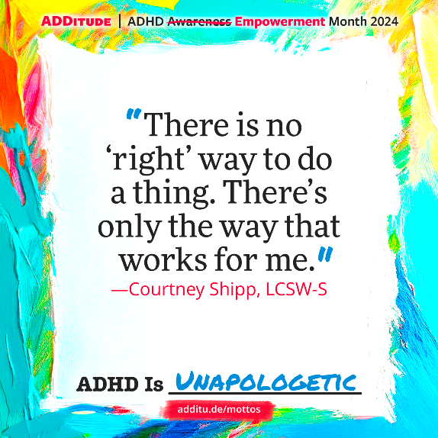

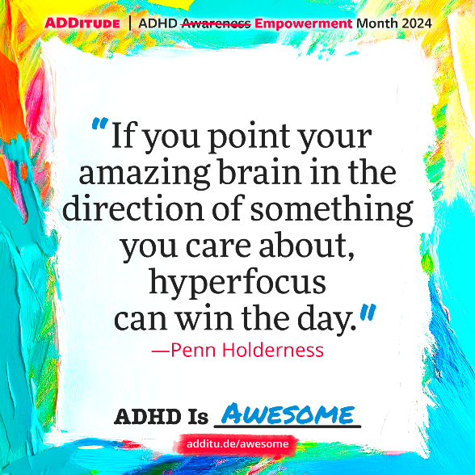
Twinkl have produced some resources for ADHD awareness month
https://www.twinkl.co.uk/search?q=ADHD+Awareness+Month&c=244&r=parent&sf=

SchoolsABC@westsussex.gov.uk
Any questions?
Contact the Learning and Behaviour Advisory Team:

