Logo, Vision and Values
Logo
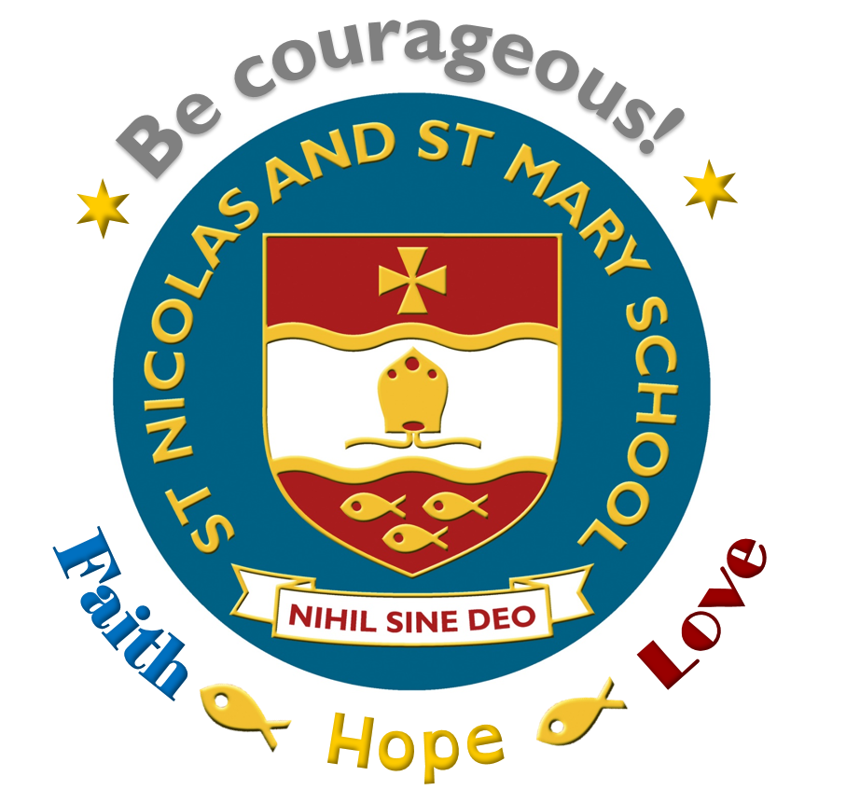
(Includes 4 key vision words and ‘Nihil Sine Deo’ = Nothing without God)

Vision Statement

Be Courageous! Live and Learn in Faith, Hope and Love
(Our aspirational forward looking statement)

Values
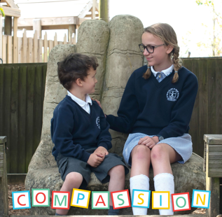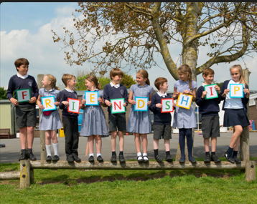
Compassion Creativity Friendship Respect
(The principles that guide us every day in all that we do)

