Monday 4th January 2021
Happy New Year! We would be very grateful if you could encourage your child to complete the three learning tasks below. Many thanks! Mrs Westcott, Miss Such and Miss Cleaver.
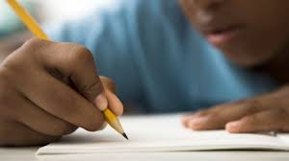  Literacy Activity:  Write a recount of the Christmas holidays. Use photos or drawings to add to your writing. Try to think about the following questions when you do your writing.  - What is your favourite memory of the Christmas holiday?  - What did you most enjoy eating/drinking?  - What was the kindest thing you did for someone else?  - What did you enjoy watching on the television?  - Did you read a really good book that you can recommend or a board game that you had fun playing?  - How did you feel when you woke up on Christmas morning?  Feel free to decorate your work, too! | Maths Activity:  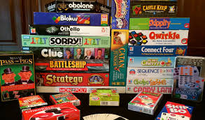  I’m sure you all played a lot of board games over Christmas but can you design your own one? Your game must include two dice and have question cards containing addition and subtraction questions. (A bit like the Chance and Community Chest cards in Monopoly.) You can decorate your game board however you like with something that interests you.
Science Activity:  This half term we are looking at the topic of ‘Animals Including Humans’. Can you think about what you ate for breakfast today? What do you know about the types of foods we should eat for breakfast? Why is breakfast such an important meal? Can you plan and draw the beat possible breakfast meal and explain your choices? | 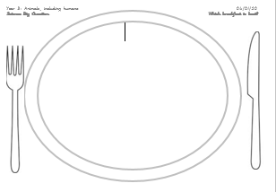  Stay safe and we will look forward to seeing you very soon.

