Ollie’s story Once upon time a puppet called Sassy was lost in the shining
rainforest. Sadly Sassy lost the other puppets in the glooming rainforest. Sassy was sad and lonely.
Suddenly Sassy found a invitation and the invitation said Sassy you are invited to Legoland.
Happily Sass was going to Legoland but snakes chased Sassy and then tied Sassy into a knot.
Happily the snakes died by a axe. The axe chopped the snakes heads off.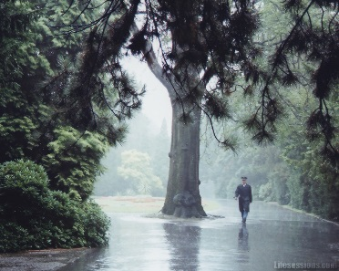
Faraway Sassy could see Lego breaking while Sassy could hear Lego breaking. Sassy could taste slimy Lego after Sassy could smell flaming fire. Sassy could feel Lego buildings and Sassy was sad and nervous because Sassy didn’t know anyone there and Sassy was a bit happy.

